CNS
Unit – 4
Q. Draw and explain UDP header format.
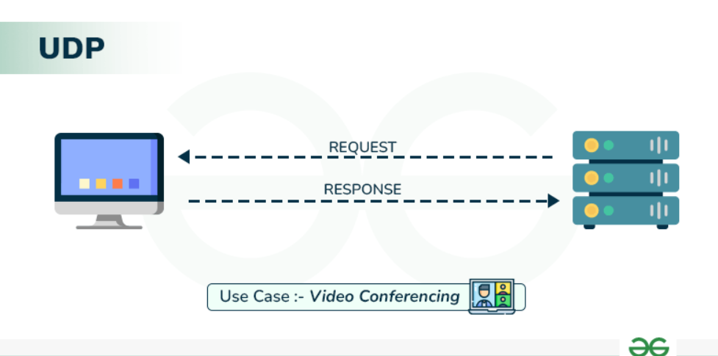
User Datagram Protocol (UDP) is a Transport Layer protocol of the Internet Protocol (IP) that provides fast, connectionless, and lightweight communication between processes. It does not guarantee delivery, order, or error checking, making it suitable for real-time and time-sensitive applications such as video streaming, DNS, and VoIP.

UDP Header
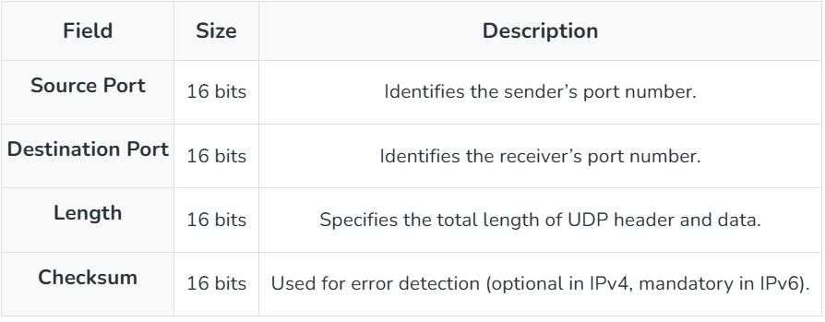
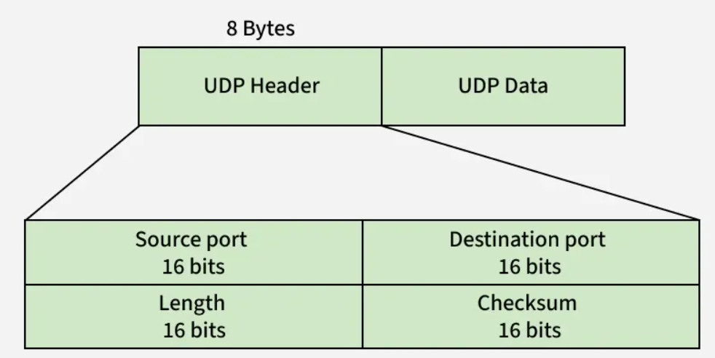
UDP header is 8 bytes long, followed by the data payload. It contains all the essential information needed for transmission. Each port number field is 16 bits, giving a range from 0 to 65535, where port 0 is reserved. Port numbers are used to identify and separate different user requests or processes.
Notes: Unlike TCP, checksum in UDP is optional, it provides no error or flow control, relying on IP/ICMP for error reporting, while port numbers help differentiate user requests.
Applications of UDP
UDP is preferred where low latency is crucial and occasional packet loss is acceptable:
- DNS uses UDP for fast query/response lookups since domain name queries are small and need quick replies.
- DHCP uses UDP to dynamically assign IP addresses to devices, where small control messages are exchanged.
- VoIP uses UDP for real-time voice communication, as it tolerates some packet loss but not delays.
- RIP uses UDP to send periodic routing updates between routers efficiently.
- NTP uses UDP to synchronize system clocks across networks with minimal overhead.
Q. Draw and explain TCP header format.
The TCP Header is like a detailed shipping label (20-60 bytes) for data, telling computers how to reliably send, receive, and reorder data packets using fields for Source/Destination Ports, Sequence/ACK Numbers (for ordering), Flags (SYN, FIN, ACK for connection control), Window Size (flow control), and Checksum (error check), plus optional info like Timestamps, ensuring reliable web browsing, email, etc..
Simple Analogy: Sending a Book by Mail
Imagine sending a large book chapter by chapter (segments) through the mail. The TCP Header is the address label and instructions on the envelope:
- Source/Destination Ports: Your house number (Source Port) and the specific person/department at the destination building (Destination Port, e.g., Port 80 for Web).
- Sequence Number: Page number (e.g., "This is page 1"). Helps reorder pages if they arrive out of order.
- Acknowledgement Number (ACK): "I've received up to page 10, send page 11 next".
- Flags (SYN, ACK, FIN, RST): Special codes: SYN (Hello!), ACK (Got it!), FIN (Goodbye!), RST (Error, restart!).
- Window Size: "I can only hold 5 pages at a time, don't send too fast!" (Flow Control).
- Checksum: A code to check if the page got smudged (corrupted) in the mail.
- Options: Extra notes like "Fragile" or specific delivery instructions (e.g., Timestamps).

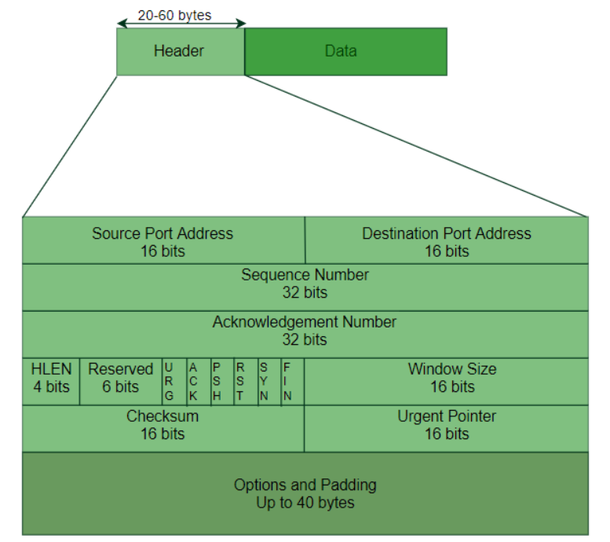
The header of a TCP segment can range from 20-60 bytes. 40 bytes are for options. If there are no options, a header is 20 bytes else it can be of upmost 60 bytes.
Header fields
1. Source Port Address: A 16-bit field that holds the port address of the application that is sending the data segment.
2. Destination Port Address: A 16-bit field that holds the port address of the application in the host that is receiving the data segment.
3. Sequence Number: A 32-bit field that holds the sequence number, i.e, the byte number of the first byte that is sent in that particular segment. It is used to reassemble the message at the receiving end of the segments that are received out of order.
4. Acknowledgement Number: A 32-bit field that holds the acknowledgement number, i.e, the byte number that the receiver expects to receive next. It is an acknowledgement for the previous bytes being received successfully.
5. Header Length (HLEN): This is a 4-bit field that indicates the length of the TCP header by a number of 4-byte words in the header, i.e if the header is 20 bytes(min length of TCP header), then this field will hold 5 (because 5 x 4 = 20) and the maximum length: 60 bytes, then it'll hold the value 15(because 15 x 4 = 60). Hence, the value of this field is always between 5 and 15.
6. Control flags: These are 6 1-bit control bits that control connection establishment, connection termination, connection abortion, flow control, mode of transfer etc. Their function is:

- URG: Urgent pointer is valid
- ACK: Acknowledgement number is valid( used in case of cumulative acknowledgement)
- PSH: Request for push
- RST: Reset the connection
- SYN: Synchronize sequence numbers
- FIN: Terminate the connection
7. Window size: This field tells the window size of the sending TCP in bytes.
8. Checksum: This field holds the checksum for error control. It is mandatory in TCP as opposed to UDP.
9. Urgent pointer: This field (valid only if the URG control flag is set) is used to point to data that is urgently required that needs to reach the receiving process at the earliest. The value of this field is added to the sequence number to get the byte number of the last urgent byte.
Q. List and explain transport layer services
The transport Layer is the second layer in the TCP/IP model and the fourth layer in the OSI model. It is an end-to-end layer used to deliver messages to a host. It is termed an end-to-end layer because it provides a point-to-point connection rather than hop-to-hop, between the source host and destination host to deliver the services reliably. The unit of data encapsulation in the Transport Layer is a segment.
Services Offered by Transport Layer
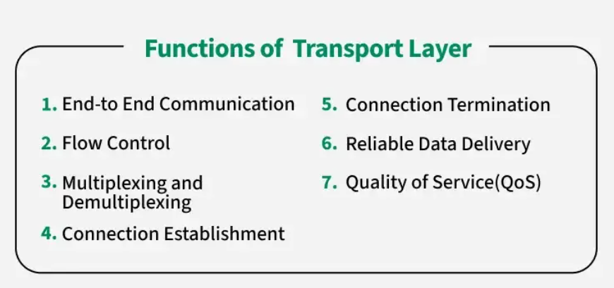
The transport layer provides reliable data transfer services such as segmentation, flow control, error detection, and retransmission, end-to-end communication between devices.
1.End-to-end Connection between Hosts
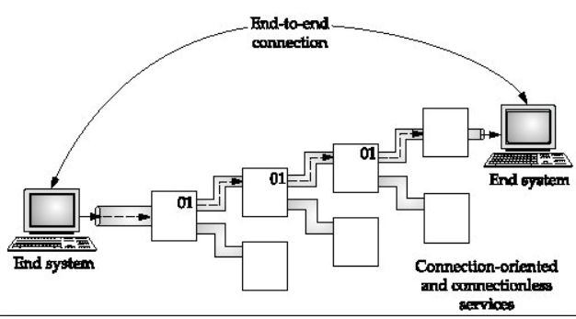
The transport layer is also responsible for creating the end-to-end Connection between hosts for which it mainly uses TCP and UDP. TCP is a secure, connection-orientated protocol that uses a handshake protocol to establish a robust connection between two end hosts. TCP ensures the reliable delivery of messages and is used in various applications. UDP, on the other hand, is a stateless and unreliable protocol that ensures best-effort delivery. It is suitable for applications that have little concern with flow or error control and requires sending the bulk of data like video conferencing. It is often used in multicasting protocols.
2.Flow Control
The transport layer provides a flow control mechanism between the adjacent layers of the TCP/IP model. TCP also prevents data loss due to a fast sender and slow receiver by imposing some flow control techniques. It uses the method of sliding window protocol which is accomplished by the receiver by sending a window back to the sender informing the size of data it can receive.
3. Multiplexing and Demultiplexing
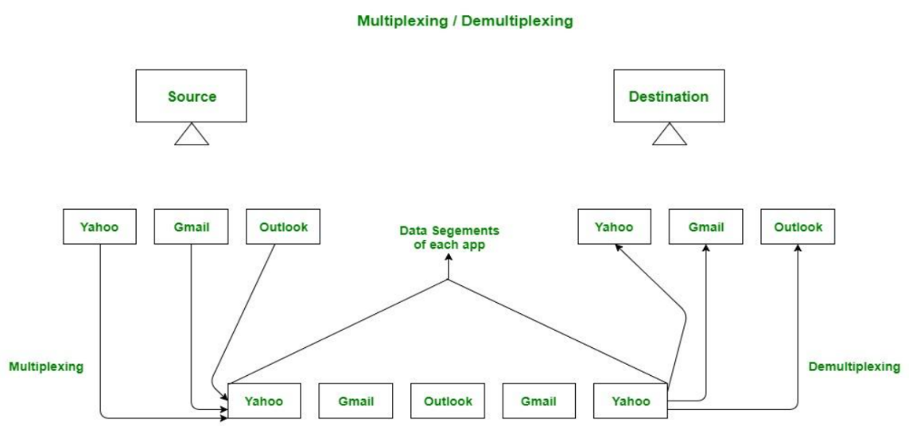
Multiplexing(many to one) is when data is acquired from several processes from the sender and merged into one packet along with headers and sent as a single packet. Multiplexing allows the simultaneous use of different processes over a network that is running on a host. The processes are differentiated by their port numbers. Similarly, Demultiplexing(one to many) is required at the receiver side when the message is distributed into different processes. Transport receives the segments of data from the network layer distributes and delivers it to the appropriate process running on the receiver’s machine.

4.Connection Establishment
When two devices in a network wants to establish a connection using TCP, it is done through 3-Way Handshake Process.
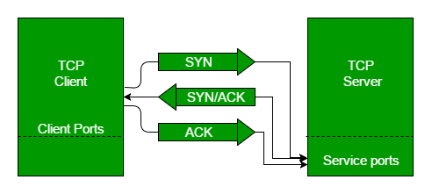
- The first computer connects to the second computer by sending a SYN packet to a specified port number.
- If the second computer is listening, it will respond with a SYN/ACK.
- When the first computer receives the SYN/ACK, it replies with an ACK packet.
- After this, the two devices can communicate normally.
5.Connection Termination
In a TCP connection, we have two types of termination mechanisms:
- In the Graceful connection release, the connection is open until both parties have closed their sides of the connection.
- In an Abrupt connection release, either one TCP entity is forced to close the connection or one user closes both directions of data transfer.
Read more about TCP Connection Termination.
6. Reliable Data Delivery
The transport layer checks for errors in the messages coming from the application layer by using error detection codes, and computing checksums, it checks whether the received data is not corrupted and uses the ACK and NACK services to inform the sender if the data has arrived or not and checks for the integrity of data.
Limitations of Transport Layer Services
- The Transport Layer does not handle routing or addressing between the source and destination. It rely on the Network Layer for this.
- Transport layer do not have features like encryption and authentication unless protocols like TLS are used.
- Reliable transmission methods like TCP add extra overhead which can slow down communication.
- The Transport Layer depends on the Application Layer for specific needs and the lower layers for handling network failure.

What are the main protocols used in the Transport Layer?
The two most common protocols are
- TCP (Transmission Control Protocol) for reliable communication
- UDP (User Datagram Protocol) for faster connectionless transmission.
Q. What is Socket? ‘What are different types of socket? Explain socket functions used in connection oriented services with diagram.
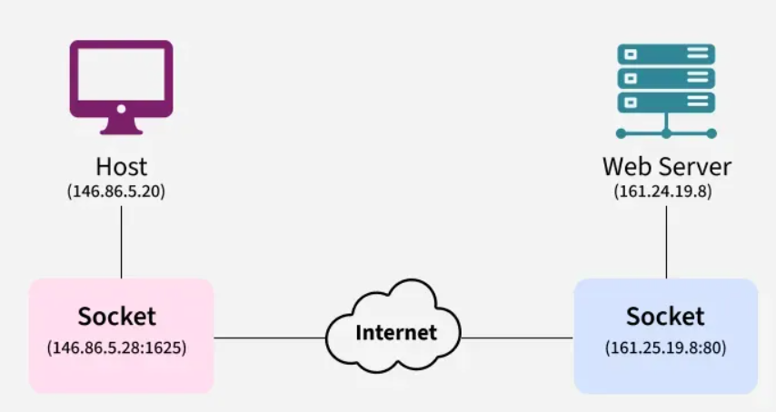
A socket is one endpoint of a two way communication link between two programs running on the network. The socket mechanism provides a means of inter-process communication (IPC) by establishing named contact points between which the communication take place.

How Sockets Work in Computer Networks
Like 'Pipe' is used to create pipes and sockets is created using 'socket' system call. The socket provides bidirectional FIFO Communication facility over the network.
- A socket connecting to the network is created at each end of the communication.
- Each socket has a specific address.
- This address is composed of an IP address and a port number.
- Socket are generally employed in client server applications.
- The server creates a socket, attaches it to a network port addresses then waits for the client to contact it.
- The client creates a socket and then attempts to connect to the server socket.
- When the connection is established, transfer of data takes place.

functions used in connection oriented services

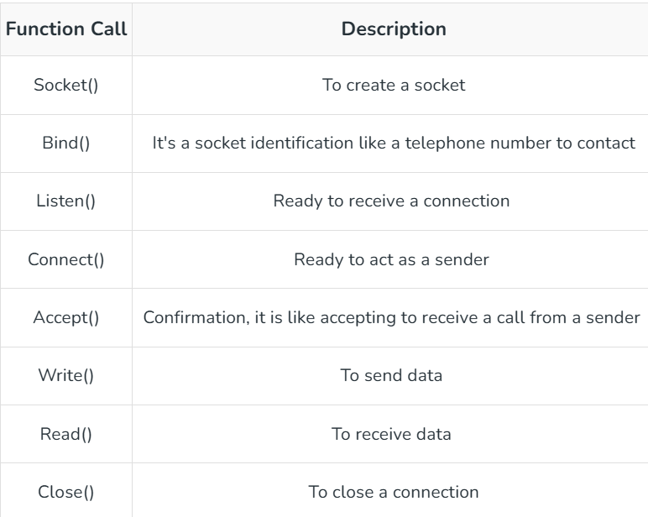
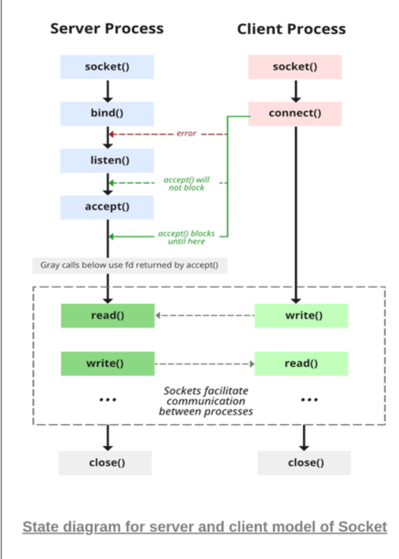

Q.Explain SCTP protocol in detail?
The Stream Control Transmission Protocol (SCTP) is an advanced transport layer protocol, sitting alongside TCP and UDP, designed for reliable, message-oriented data transfer in computer networks [1]. It was developed by the Internet Engineering Task Force (IETF) and provides several key features not found in its predecessors.
Here is a detailed explanation of SCTP in simple terms:
What is SCTP?
Think of SCTP as a more robust version of TCP, specifically engineered to handle the demands of modern applications, especially telecommunications signaling (like VoIP). While TCP is designed to move a single, continuous stream of bytes reliably, SCTP is designed to move independent messages reliably.
Key Features of SCTP
SCTP offers several advantages over TCP and UDP:
1. Message-Oriented (Preserves Message Boundaries)
Unlike TCP, which treats data as a continuous flow of bytes, SCTP understands where one message begins and another ends [2]. If you send three 100-byte messages, the receiver will receive exactly three 100-byte messages, preserving the structure of the data.
2. Multi-homing (Connection Redundancy)
This is a major feature. A single SCTP connection (called an association, not a connection) can span across multiple network interfaces (IP addresses) on a device [1].
- Simple terms: If your main internet connection fails, SCTP can automatically and seamlessly switch the data transfer to a backup connection (e.g., a secondary Wi-Fi or cellular link) without interrupting the application [1]. This provides high availability and fault tolerance.
3. Multi-streaming (Eliminates Head-of-Line Blocking)
In TCP, if one data packet is lost, all subsequent data must wait for that single missing packet to be resent, even if it belongs to an entirely different part of the application (this is called Head-of-Line Blocking) [1].
- Simple terms: SCTP splits the data into independent logical "streams" within a single association [2]. If a packet in Stream 1 is lost, data in Stream 2 can continue to be delivered to the application without delay. This is excellent for applications sending multiple types of data simultaneously.
4. Reliable Data Transfer (Like TCP)
SCTP guarantees that all data will arrive at the destination, in order (within each stream), and without corruption [2]. It uses mechanisms like sequence numbers, acknowledgements (ACKs), and retransmission timers, similar to TCP's reliability model.
5. Enhanced Security Handshake
SCTP uses a more secure 4-way handshake process to establish an association, rather than TCP's 3-way handshake [2]. This helps protect against denial-of-service (DoS) attacks, such as the SYN flood attack that targets TCP handshakes [2].
SCTP vs. TCP vs. UDP
Feature | TCP (Transmission Control Protocol) | UDP (User Datagram Protocol) | SCTP (Stream Control Transmission Protocol)
Reliability | Yes (Guaranteed) | No (Best effort) | Yes (Guaranteed)
Data Type | Byte stream | Datagrams (Messages) | Message stream
Ordering | In-order | No specific order | In-order (within a stream) [2]
Head-of-Line Blocking | Yes | No | No (due to multi-streaming)
Multi-homing | No | No | Yes
Handshake | 3-way | Connectionless | 4-way [2]
Common Use Cases
While TCP handles most web traffic (HTTP/HTTPS), SCTP is commonly found in specialized environments:
- Telecommunications: It is widely used for signaling protocols like SS7 and SIP (Session Initiation Protocol) that manage phone calls and mobile network operations, where reliability and redundancy are critical [1, 2].
- Industrial Systems: Applications requiring high availability and seamless failover between network paths often utilize SCTP.
In summary, SCTP combines the reliability of TCP with the message preservation of UDP, adding advanced features like multi-homing and multi-streaming to create a highly resilient and efficient transport protocol.

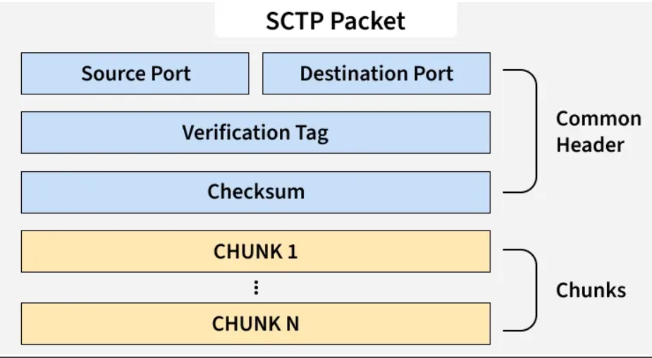
SCTP Packet Structure

An SCTP packet has two main parts- Header and Payload. The Header is common but Payload have variable chunks.
The Common SCTP header is 12 byte long and made of the 4 parts:
- Port Number (Source): shows the sending port
- Port Number (Destination): shows the receiving port
- Verification tag: a 32 bit random value which differentiate the packets from the previous connection
- Checksum: a CRC32 algorithm for detection of error.

Q.Explain TCP congestion control in transport layer
TCP Congestion Control is like a smart traffic cop for the internet, preventing too much data (traffic) from overwhelming the network by making senders slow down when things get busy and speed up when clear, using a "Congestion Window" to manage how much data is sent at once, reducing packet loss and keeping the internet smooth. It starts slow (Slow Start), quickly ramps up, then slows if packets are dropped (congestion), and carefully increases again (Congestion Avoidance) to find the network's sweet spot, ensuring fairness and stability.
The Analogy: A Highway
- Too Many Cars (Congestion): When too many cars (data packets) try to use a highway (network) at once, traffic jams (congestion) occur, cars get stuck, and some might even get lost (packet loss).
- TCP's Role: TCP acts as the traffic controller, telling drivers (senders) to slow down or speed up to keep traffic flowing smoothly.

How TCP Does It (The Algorithm)
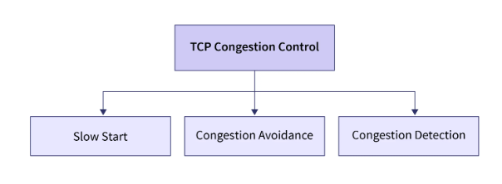
- Slow Start (Ramping Up):
  - At the start of sending data, TCP sends a little bit, then waits for confirmation (acknowledgment).
  - For each confirmation received, it doubles the amount of data it sends next time, growing quickly but cautiously.
  - Example: Send 1, get ACK, send 2. Get ACKs for those, send 4, then 8, and so on (exponential growth).
- Congestion Avoidance (Steady Cruise):
  - Once the window (amount of data in flight) reaches a certain limit (threshold), TCP slows down its rapid increase.
  - Instead of doubling, it adds just one segment (or a fixed small amount) for each round trip (RTT), moving carefully to avoid overload.
- Detecting Congestion (Traffic Jam!):
  - The main sign of congestion is packet loss, often seen as a router dropping packets because its buffer is full.
  - When TCP doesn't get an ACK for a packet (a timeout or duplicate ACKs), it knows something's wrong.
- Reacting to Congestion (Slowing Down):
  - Upon detecting congestion, TCP drastically cuts its sending rate (often halving the window size).
  - It then goes back to Slow Start or enters a more careful Congestion Avoidance phase to find a new, stable rate.

Key Terms
- Congestion Window (cwnd): The limit on how much unacknowledged data TCP can send.
- Packet Loss: When routers drop packets because networks are overloaded, signaling congestion.
- Acknowledgment (ACK): A message from the receiver confirming data arrived safely.
In short, TCP congestion control uses a feedback loop of sending, receiving ACKs, detecting losses, and adjusting its "window" to keep data flowing efficiently, preventing network collapse.
Q. What is Quality of Service? Explain any two methods to improve QoS?
In simple terms, Quality of Service (QoS) in networking is like having traffic lights and lanes on a highway for data, ensuring important stuff (like video calls) gets through smoothly, even when busy, by managing delay, jitter (unevenness), and packet loss. Two ways to improve it are Traffic Shaping, which smooths out bursts of data by holding excess in a queue (like a buffer) to prevent network jams, and Priority Queuing, which sorts data into different lanes (high, medium, low) so critical data always goes first, ensuring smooth voice/video calls over slow networks.
What is QoS?
- It's a set of tools to control network traffic, making sure critical applications (VoIP, video) work well, even if the network is overloaded.
- It prioritizes data, reduces delays (latency), minimizes packet loss, and controls jitter (variation in delay) for a better user experience.
Two Methods to Improve QoS
- Traffic Shaping (Smoothing Out Traffic)
  - How it works: Imagine a busy road where cars suddenly speed up – it causes jams. Traffic shaping is like a traffic controller putting up a temporary speed limit sign, making cars slow down and space out.
  - In networking: It buffers (holds) excess data packets in a queue and releases them at a steady, controlled rate, preventing sudden bursts that overwhelm the network.
  - Benefit: Prevents congestion and ensures a predictable flow, great for smooth streaming.
- Priority Queuing (Sorting Traffic by Importance)
  - How it works: Think of an emergency lane on a highway. Ambulances (high priority) get to go first, even if regular cars (low priority) are waiting.
  - In networking: Packets are put into different queues based on their importance (e.g., Voice gets Highest, Video gets High, Email gets Low).
  - Benefit: High-priority traffic (like a voice call) always gets processed first, ensuring clear conversations, while lower-priority data waits, keeping critical services running.

Q.Explain RTP protocol in detail.
RTP (Real-Time Transport Protocol) is like a special delivery service for live audio & video (think Zoom, streaming) over the internet, using UDP for speed (less overhead) but adding crucial features: timestamps to keep audio/video in sync, sequence numbers to reorder lost/delayed packets, and working with RTCP (Real-Time Transport Control Protocol) for quality feedback (jitter, loss), ensuring smooth, real-time delivery for things like VoIP, video calls, and live streams.
How RTP Works (Simple Analogy)
Imagine sending a live concert video:
- Breaking it Down (Packetization): The big video/audio file is chopped into small video/audio "clips" (packets).
- Labeling (Timestamp & Sequence Number): Each clip gets a timestamp (when it was recorded) and a sequence number (1st, 2nd, 3rd...).
- Sending (Using UDP): These clips are sent quickly via UDP (User Datagram Protocol), which is fast but doesn't guarantee delivery, like sending postcards – some might get lost.
- Reassembly & Syncing (Receiver): Your device gets the clips, uses the sequence numbers to put them in order, and uses timestamps to play audio and video together smoothly.
- Quality Check (RTCP): A separate helper (RTCP) sends back reports: "Hey, we're missing clip #5!" or "The clips are arriving too jittery!".
- Adjusting (Feedback Loop): The sender might then slow down or change quality based on RTCP's feedback to improve things.
Key Components & Terms
- UDP (User Datagram Protocol): RTP runs on top of UDP because UDP is fast (connectionless, no big handshake), ideal for speed over guaranteed delivery.
- RTCP (Real-Time Transport Control Protocol): The "quality control" partner. It monitors & sends reports on jitter (timing variation), packet loss, and sync, while RTP just carries the media.
- SIP (Session Initiation Protocol): Often used with RTP to set up, manage, and end the call/session (like finding your friend to call) before RTP starts streaming.
- Jitter: Variation in packet arrival time; RTP/RTCP helps smooth this out.
Where You See RTP
- VoIP: Your calls on apps like WhatsApp, Skype.
- Video Conferencing: Zoom, Google Meet.
- Live Streaming & IPTV: YouTube Live, online TV.
In short, RTP is the backbone for smooth, real-time multimedia, making sure your video and audio arrive in sync, even if the internet isn't perfect.
Q.For each of the following applications, determine whether TCP or UDP is used as the transport layer protocol and justify the reason(s) for your choice. i) File Transfer ii) Watching a real time streamed video iii) Web browsing iv) A Voice over IP (VoIP) telephone conversation. v) YouTube video
Here is the determination of whether TCP or UDP is used for each application, with justification:
- i) File Transfer: Uses TCP.
  - Reason: TCP is connection-oriented and provides reliable, error-free, and ordered delivery of data. When transferring files, it is crucial that all data arrives intact and in the correct order to ensure the file is not corrupted.
- ii) Watching a real time streamed video: Primarily uses UDP, though TCP can also be used in some cases.
  - Reason (UDP): Real-time applications prioritize speed and low latency over perfect reliability. A lost packet results in a minor, momentary glitch in the video, which is preferable to the significant delay (buffering) that would occur if the system had to wait for lost packets to be retransmitted (as in TCP).
  - Reason (TCP): Some streaming services, like YouTube, may use TCP to ensure higher quality playback when bandwidth allows, as TCP guarantees all data arrives without loss or corruption. However, UDP is more common for strict real-time requirements where delay is the primary concern.
- iii) Web browsing: Uses TCP.
  - Reason: Web browsing (using HTTP or HTTPS) requires the reliable and complete transfer of all components of a webpage (HTML, images, etc.). TCP's mechanisms, such as connection establishment, error checking, and retransmission of lost packets, ensure that the page loads correctly and completely.
- iv) A Voice over IP (VoIP) telephone conversation: Uses UDP.
  - Reason: Similar to video streaming, VoIP is a real-time application where low latency is critical for a natural conversation. It can tolerate some minor data loss (a brief audio dropout) because waiting for retransmission would cause unacceptable delays and disrupt the flow of the conversation.
- v) YouTube video : YouTube primarily uses TCP for video delivery.
  - Reason: While real-time video can use UDP, major platforms like YouTube often prioritize the reliability and guaranteed delivery offered by TCP. This ensures high-quality video playback without missing data or corruption, leveraging TCP's flow control and retransmission capabilities. The system buffers the video to account for latency, prioritizing data integrity over absolute minimum delay in this context.
Q.Explain TCP connection establishment process with suitable diagram
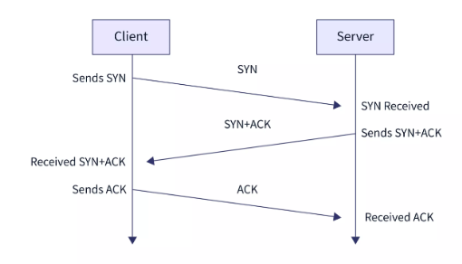
The TCP connection establishment uses a Three-Way Handshake (SYN, SYN-ACK, ACK) to reliably set up a connection, ensuring both client and server are ready, synchronizing sequence numbers, and agreeing on initial parameters before data transfer begins. It involves three steps: Client sends SYN (synchronize), Server replies with SYN-ACK (acknowledges SYN, sends its own SYN), and Client sends final ACK (acknowledges server's SYN), transitioning both to the ESTABLISHED state.

TCP Three-Way Handshake Steps
1. Client to Server: SYN
- The client initiates the connection by sending a TCP segment with the SYN (Synchronize) flag set to 1.
- It includes a random Initial Sequence Number (ISN) (e.g., 𝑋) to track data flow.
- Diagrammatically: Client (SYN, Seq=X) --> Server
2. Server to Client: SYN-ACK
- The server receives the SYN, allocates resources, and responds with a segment that has both the SYN and ACK (Acknowledge) flags set.
- It acknowledges the client's SYN by setting the ACK number to 𝑋+1 (expecting the next byte).
- It sends its own random ISN (e.g., 𝑌) for its data flow.
- Diagrammatically: Server (SYN-ACK, Seq=Y, Ack=X+1) --> Client
3. Client to Server: ACK
- The client receives the SYN-ACK and sends a final segment with the ACK flag set.
- It acknowledges the server's SYN by setting the ACK number to 𝑌+1.
- Diagrammatically: Client (ACK, Seq=X+1, Ack=Y+1) --> Server
Result: The connection is now established (ESTABLISHED state), and data transfer can begin.

Q. explain TCP state transition diagram?
A TCP State Transition Diagram shows how a connection changes "states" (like CLOSED, LISTEN, ESTABLISHED) based on events (like sending/receiving messages) to manage reliable data flow, using circles for states and arrows for transitions labeled with events/actions (e.g., SYN/ACK) for establishing, transferring, and closing connections. It's a map of TCP's life cycle, from starting fresh (CLOSED) to active chatting (ESTABLISHED) and saying goodbye (TIME_WAIT), ensuring both sides agree on communication.
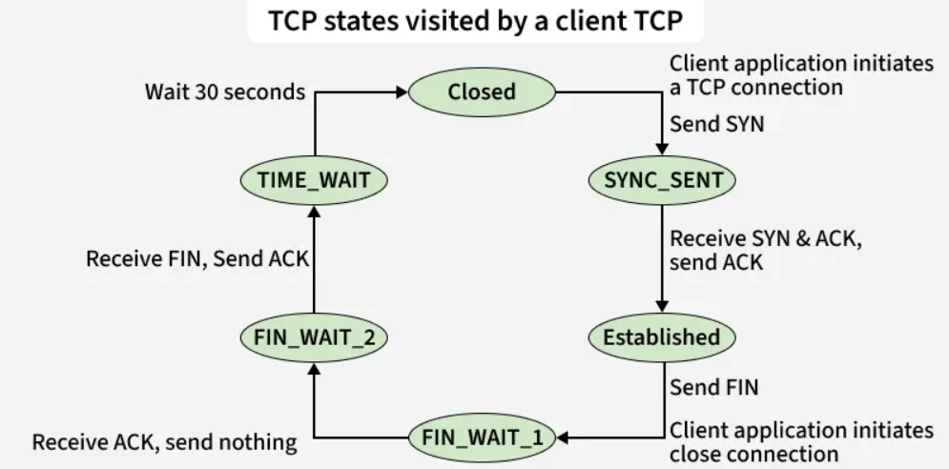
Simple Explanation:
Imagine TCP as a phone call between two friends (Client & Server).
- CLOSED (Idle): No call is happening.
- LISTEN (Server): Server waits for someone to call (LISTEN state).
- SYN_SENT (Client): Client calls out (sends SYN packet) and waits (SYN_SENT).
- SYN_RCVD (Server): Server gets the call, says "Hi, I hear you!" (sends SYN-ACK) and waits for confirmation (SYN_RCVD).
- ESTABLISHED (Both): Client says "Got it!" (sends ACK), and the real talk (data transfer) begins!
- FIN-WAIT/TIME-WAIT (Closing): When done, they send FIN (finish) signals, move through states like FIN-WAIT (waiting for ACK) and TIME-WAIT (brief pause to ensure all messages clear), before finally returning to CLOSED.
Key Components:
- States (Circles): Different conditions of the connection (e.g., LISTEN, SYN_SENT, ESTABLISHED, TIME_WAIT, CLOSED).
- Events/Actions (Arrows): What triggers a change (e.g., a SYN packet arrives, an application asks to connect/close).
- Three-Way Handshake: The SYN (Client) -> SYN-ACK (Server) -> ACK (Client) process to start the connection.
- Data Transfer: Once ESTABLISHED, data flows reliably, confirmed by ACKs.
- Connection Termination: Handled by FIN/ACK exchanges, moving through states like FIN-WAIT-1, FIN-WAIT-2, LAST_ACK, and TIME_WAIT to ensure a clean end.

Why it's used:
It visually defines how TCP manages the entire lifecycle of a connection, ensuring reliability and order, which is crucial for things like web browsing and file transfers
Q. What causes silly window syndrome? How is avoided? Explain.
Silly Window Syndrome (SWS) is when TCP sends tiny, inefficient packets (like 1 byte) instead of large chunks, wasting bandwidth due to header overhead, caused by slow senders (sending byte-by-byte) or slow receivers (consuming byte-by-byte), but is avoided by Nagle's Algorithm (sender buffers small data) and Clark's Solution (receiver waits to advertise large window), ensuring bigger, more efficient data chunks are sent.
What Causes Silly Window Syndrome?
Imagine a truck (packet) delivering furniture (data).
- Sender Side (Slow Sender): An application sends data one byte at a time. The sender puts that single byte in a truck (packet) and sends it immediately. This means lots of tiny trucks for very little furniture, wasting fuel (bandwidth) on the truck's size (header).
- Receiver Side (Slow Receiver): The receiver's buffer (storage space) fills up quickly. It tells the sender to send less (smaller window). The sender then sends tiny packets, even if the receiver could take more if it cleared space faster. The receiver keeps saying "send 1 byte," and the sender keeps sending 1 byte, leading to inefficient “thrashing”.
How is it Avoided?
Solutions ensure larger, more efficient data chunks are sent:
- Nagle's Algorithm (Sender Fix): The sender waits to collect more data from the application before sending. It buffers small amounts and sends them all at once after getting an acknowledgment (ACK) for the first byte, combining them into one larger packet.
- Clark's Solution (Receiver Fix): The receiver delays sending window updates (how much space it has). Instead of announcing a tiny 1-byte window, it waits until its buffer has significantly more space (e.g., a full segment or half its buffer) before telling the sender, allowing larger sends.
In Simple Terms: SWS is like sending a big truck to deliver one small item. Nagle's algorithm tells the sender to wait and fill the truck before sending, while Clark's solution tells the receiver to wait until it has space for many items before telling the sender to bring more.

Q. Following is a dump of UDP header in Hexadecimal format 06 32 00 0D 00 1C E2 17
i) What is source port number? ii) What is destination port number? iii) What is total length of the user datagram? iv) What is the length of the data? v) Is packet directed from a client to server or vice versa? vi) What is the client process?
Here are the details extracted from the provided UDP header in hexadecimal format (
06 32 00 0D 00 1C E2 17):
i) What is source port number?
The source port number is derived from the first two bytes (06 32).
- Convert 06 32 from hexadecimal to decimal:
$$\left(0632)_{16}=0×{16}^{3}+6×{16}^{2}+3×{16}^{1}+2×{16}^{0}=0+1536+48+2=1586\right.$$
(0632)16=0×163+6×162+3×161+2×160=0+1536+48+2=1586
.
- Source port number: 1586
ii) What is destination port number?
The destination port number is derived from the next two bytes (00 0D).
- Convert 00 0D from hexadecimal to decimal:
$$\left(000D)_{16}=0×{16}^{3}+0×{16}^{2}+0×{16}^{1}+13×{16}^{0}=0+0+0+13=13\right.$$
(000𝐷)16=0×163+0×162+0×161+13×160=0+0+0+13=13
.
- Destination port number: 13
iii) What is total length of the user datagram?
The total length of the user datagram (header + data) is derived from the fifth and sixth bytes (00 1C).
- Convert 00 1C from hexadecimal to decimal:
$\left(001C)_{16}=0×{16}^{3}+0×{16}^{2}+1×{16}^{1}+12×{16}^{0}=0+0+16+12=28\right.$.

Total length: 28 bytes

iv) What is the length of the data?
The UDP header is a fixed size of 8 bytes.
- Data length = Total length - Header length
- Data length = 28 bytes - 8 bytes = 20 bytes.
- Length of the data: 20 bytes
v) Is packet directed from a client to server or vice versa?
The direction is determined by the port numbers.
- Source port (1586): This is an ephemeral port number (typically above 1023), dynamically assigned to a client process.
- Destination port (13): This is a well-known port number, specifically assigned to the Daytime service, which is a standard server process.
- Therefore, the packet is directed from a client to a server.
vi) What is the client process?
A client process in a computer networking system is a program or application that initiates a request for a service or resource from another program, known as a server, over a network.
In simple terms:
- The client is like a customer in a restaurant who places an order.
- The server is like the cook or waiter who receives the order, prepares the food, and sends it back to the customer.
- The client is responsible for interacting with the user and sending requests, while the server manages and provides the requested resources or data.
- The specific client process here is likely an application or script making a request to the Daytime service running on port 13. The Daytime protocol typically returns the current date and time in a human-readable format.

